GitHub - Mohammed-3tef - Computer_Science_Books
# Source: ScreenShots Source: Provided by: [Persons Table -> ID Column: 1, Name_En Column: Motasem Essam] -> Tool: [Lightshot Program] -> From [Site: https://welib.org/] on [4/21/2025]
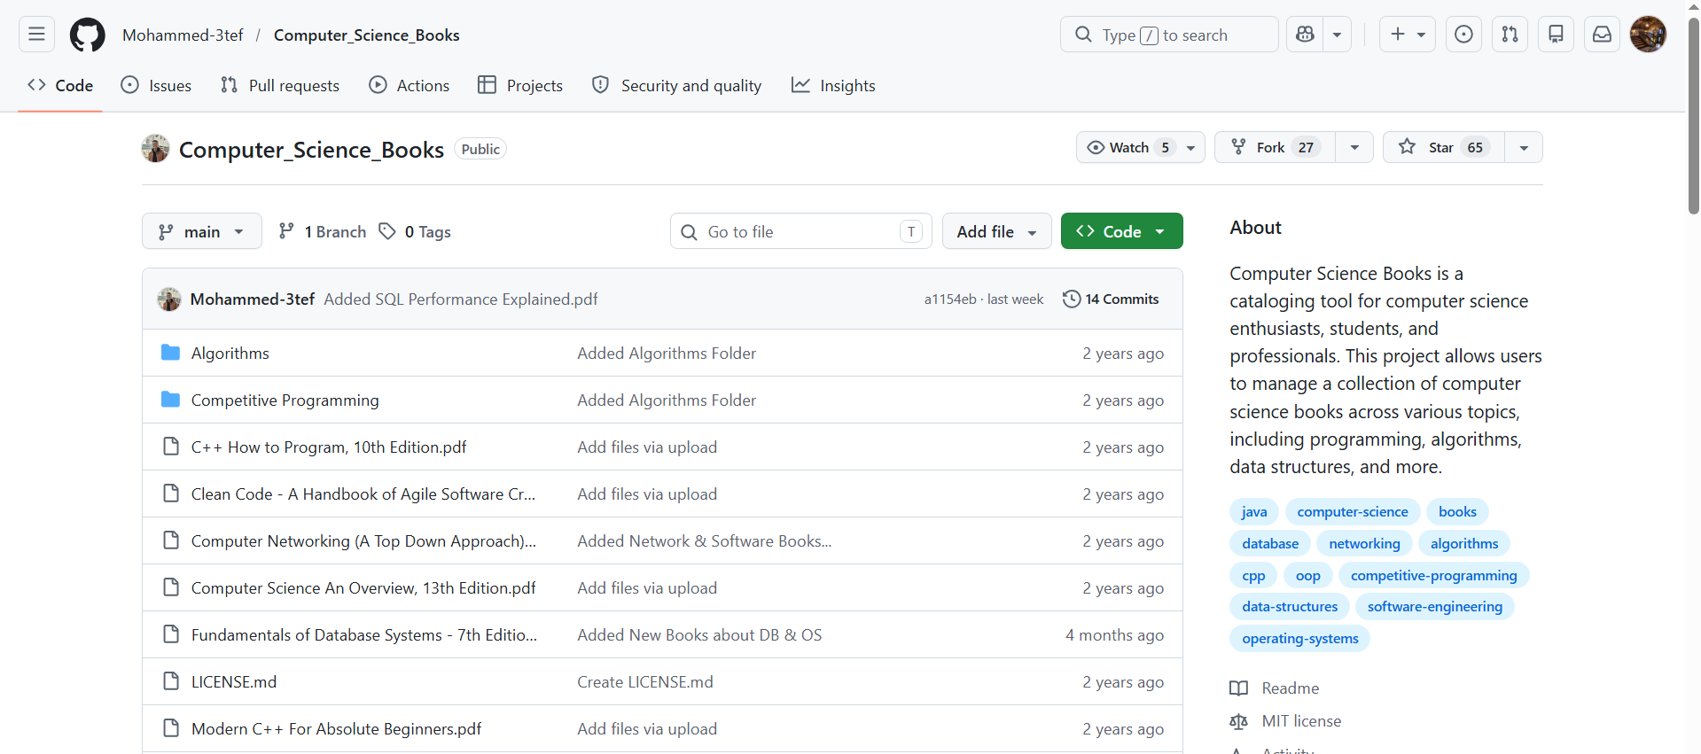
# Source: Person Source: Provided by: [Data Path: Persons Table -> ID Column: 1, Name_En Column: Motasem Essam] Written by: [Data Path: Persons Table -> ID Column: 1, Name_En Column: Motasem Essam] on [4/21/2026]
https://github.com/Mohammed-3tef/Computer_Science_Books/tree/main

